 |  |  |  |  |  |  | PO Box 86  317 Vance St.
 |  |  |  |  |  |  | Forest City, NC 28043
 |  |  |  |  |  |  | Phone: 1-800-433-INKS
 |  |  |  |  |  |  | Fax: 828-247-0705
 | TECH-TALK
PRODUCT NAME: | Film SP Ink System
DESCRIPTION: | High Strength System with excellent adhesion to various Films that is
 | designed to be overprinted or laminated.
SUBSTRATES: | Film, Foils, and Paper
PROPERTIES:
VISCOSITY: | 16 - 32" #3 Zahn
pH: | 8.8 - 9.4
RUN SPEED: | 100 - 300 FPM
HEAT RESISTANCE: | Not Recommended
LIGHT FASTNESS: | Available in Lightfast and Non-lightfast
WATER RESISTANCE: | Very Good to excellent
REDUCERS: | Blend 98/2, water/pH
ANILOX: | Solids 400-600 line, Process 800-1200 line
DOCTOR BLADE: | Recommended
METER BALL:
 | 50-75 durometer roller
DRYING CAPABILITIES:
 | Medium to Hot Forced Air volume
PRESS SIDE PROCEDURES
Pour ink into pan straight. Start press and pull up color to determine strength. If color strength
needs adjusting, we recommend changing anilox before adjusting ink.
If color pulls up strong and you want to reduce, use blend of 98/2, water/pH adjuster.
Extend color using AWG-0252V Film SP Transparent White.
Propylene Glycol can be added up to 5% by weight for slower press speeds.
If higher press speeds are needed, use a blend of water/alcohol. Keep in mind that using this
blend will lower your pH. So, check you pH after each add and raise as needed.
END USE RESTRICTIONS
NOT INTENDED FOR USE IN THE FOLLOWING APPLICATIONS:
WET APPLICATIONS WHICH INCLUDE -
 |  |  |  |  |  | Steam
 |  |  |  |  |  | Autoclave
LIGHTFASTNESS - |  |  |  |  |  | N/A
HEAT RESISTANT - |  |  |  |  |  | Up to 300º Fahrenheit
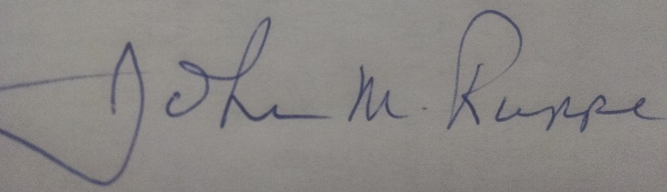 |  |  |  |  |  |  |  | 02/23/15
John M. Ruppe, Jr. - President |  |  |  |  |  |  |  | Date:

